3D CUBE ANALYSIS SYSTEM
Presented by ☺ KRISHNA KUMAR
krishx007@yahoo.com

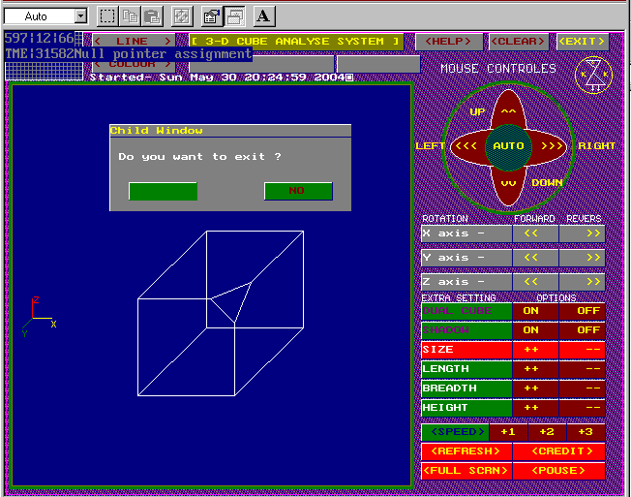

Contents:
Introduction
Objective
Need of 3D cube analysis system
Hardware Requirements
Software Requirements
Description of the project and User Interface
Merits and Demerits

Introduction:

This GUI program is programmed in C++. This is a very useful program for analyzing a 3D object. Borland Turbo C++ 3.0 is used for compilation of this graphics program.

This is a program for analyzing 3-DIMENSIONAL CUBE or CUBOID.
Generally students or people face problems to understand 3-D figures in engineering drawing. the rotation of 3D cube about X, Y and Z axis. From this software we can understand all things easily. We can rotate the cube about all three axis both “forward and reverce”direction.
Even you can keep the cube in automatic rotation from AUTO button in the center. We can change CUBE INTO CUBOID with your required shape & size from “EXTRA SETTING”.
This is a GUI program very interactive, so we can simply operate it. We can write or highlight any thing in CUBE SCREEN. For restoring the position of 3D cube we can refresh it by REFRESH button.
This program require EGAVGA.bgi file, which is a VGA graphics driver for Turbo C++. And one *.chr file.

Objective:

The objective of this program is to help engineering students in engineering drawing.

Students can see the rotation of 3-D cube in a 3-D space in real time, so the students can avoid confusion in understanding the rotation or position of 3-d objects in 3-d space.

This is a very interactive GUI program so you can understand and simply operate it.

Need of 3D cube analysis system

For understanding the fundamental of engineering drawings.

For getting the concrete idea about the position of 3D object in 3D space, in real time mode.

Description of Project

This project has a wide scope in engineering drawing. Its real time simulation of 3-D object in 3-D space makes better understanding and conception of engineering drawing.

The inputs of this GUI program are mainly classified in four groups.
- The first group of input buttons is dedicated to for the displacement of 3-D objects in X, Y plane.
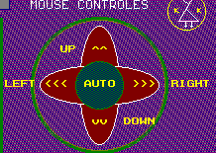

- The second groups of input buttons are for changing the rotation of 3-D objects in forward and in reverse direction in x, y & z plan.

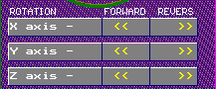

- Third groups of inputs are dedicated to customize the length, breadth and height of the cube.

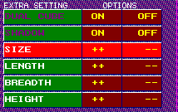

- The last group is for changing the rotation speed of 3D objects and some extra features.



Hardware requirement
- VGA or higher-resolution screen supported by Microsoft Windows.

- 32 MB of RAM.

- Intel Pentium III or higher

- A mouse or other suitable pointing device

- Integrated audible bell

Software requirement
The following languages and software are used:
Borland Turbo C++ 3.0

Windows 98,Windows 2000 or Windows XP

Size of files

3D-ANALY.EXE 82kb
EGAVGA.BGI 6kb

Merits

- Interactive graphical user interface.

- Real time rotation of 3D objects .

- A number of inputs functions are available for customizing the 3 D objects.

- Inbuilt sound functions are included.

Demerits

- Only 3d cube is provided, also there should be the option cone, hexagone, and sphere.

- There is no function to see the 3 d object in front view, top view, and side view.

- This program is a very preemptive type, so there is no an advance function or options.

- There is no option for saving the position and customize size of 3d cube.

